Problem Statement:
ABC Fashion is a leading retailer with a vast customer base and a team of dedicated sales representatives. They have a Sales Order Processing System that helps manage customer orders and interactions.

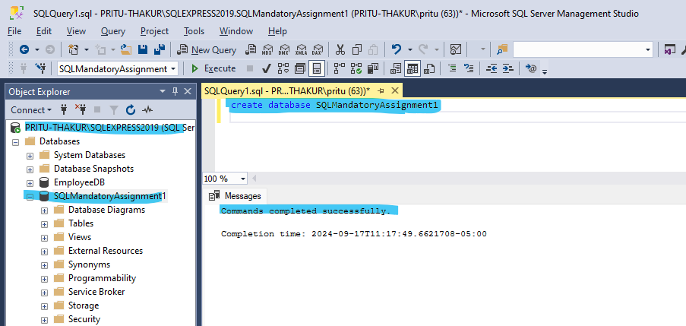

Dataset given
- Salesman Table Created
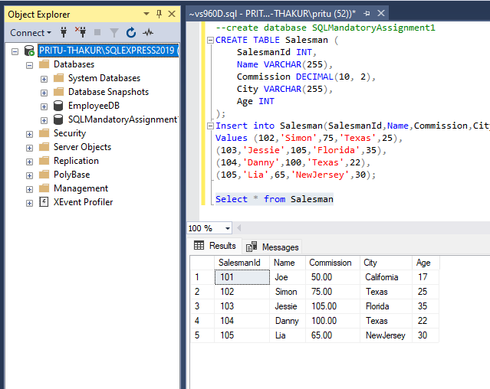
- Customer Table created with given dataset
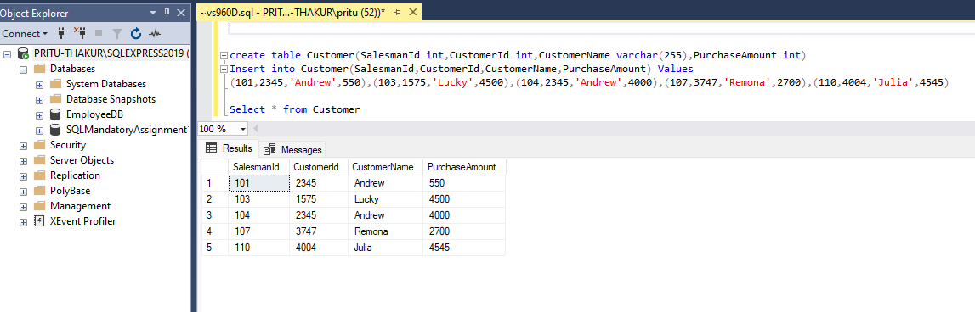

- Orders Table creation with given Dataset.
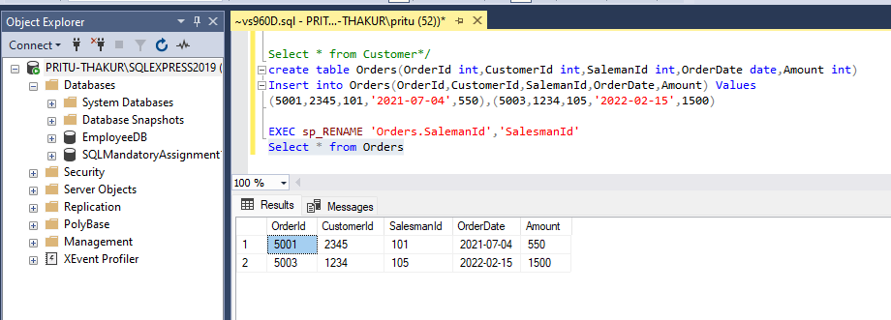

TASKS
- Insert a new record in Orders Table
Query - Insert into Orders (OrderId,CustomerId,SalesmanId,OrderDate,Amount)
values (5004,1575,103,'2024-06-29',4500)

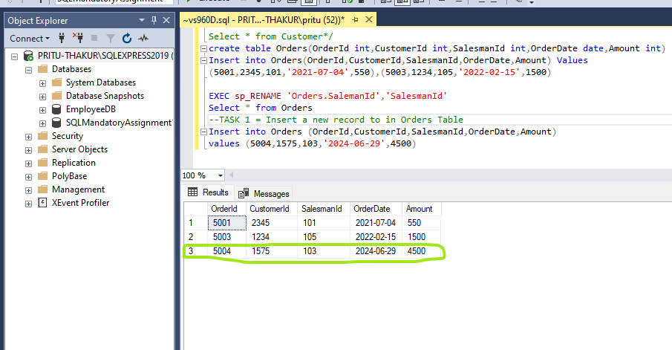

2. Add Primary key constraint for SalesmanId column in Salesman table. Add default constraint for City column in Salesman table. Add Foreign key constraint for SalesmanId column in Customer table. Add not null constraint in Customer_name column for the Customer table.
2.a Add Primary key constraint to Salesman ID column
Primary key constraint cannot be added to a nullable column so first add Not Null constraint and then Primary key constraint.

Query - ALTER TABLE Salesman alter column SalesmanId int not null
ALTER TABLE Salesman ADD CONSTRAINT PK_Salesman PRIMARY KEY(SalesmanId)

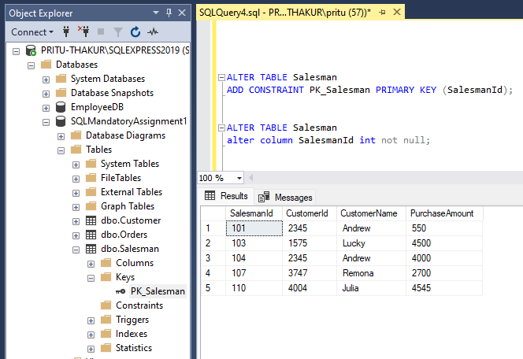

2.b Add default constraint for City column in Salesman table
Query - ALTER TABLE Salesman add constraint df_city Default'SanJose' for city

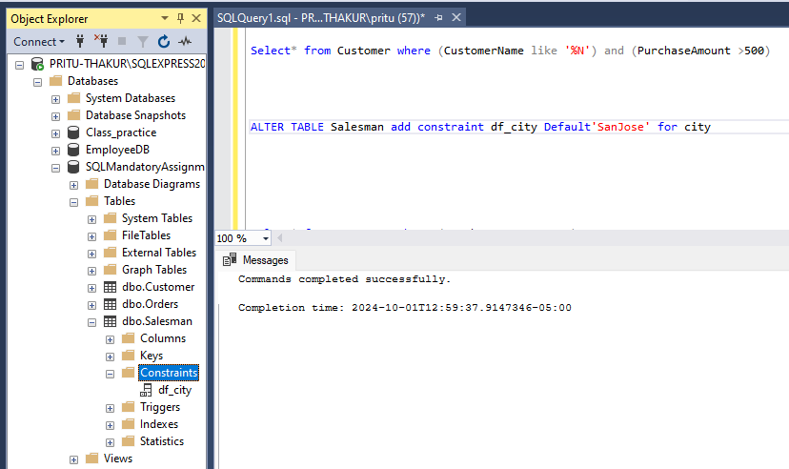

2.c Add Foreign key constraint for SalesmanId column in Customer table.

Query - ALTER TABLE Customer with nocheck ADD CONSTRAINT fk_Salesman_Customer FOREIGN KEY (SalesmanId) REFERENCES Salesman (SalesmanId)

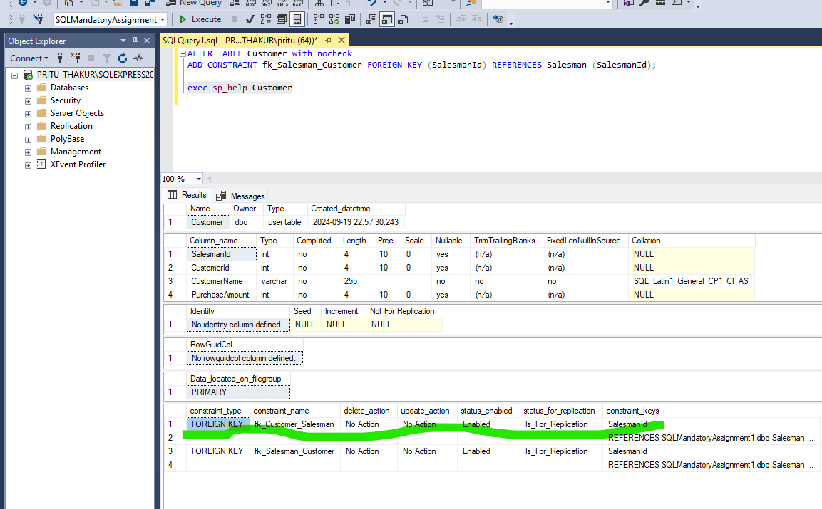

2.d Add not null to customer name column.
Query - Alter table Customer Alter column CustomerName varchar (255) not null
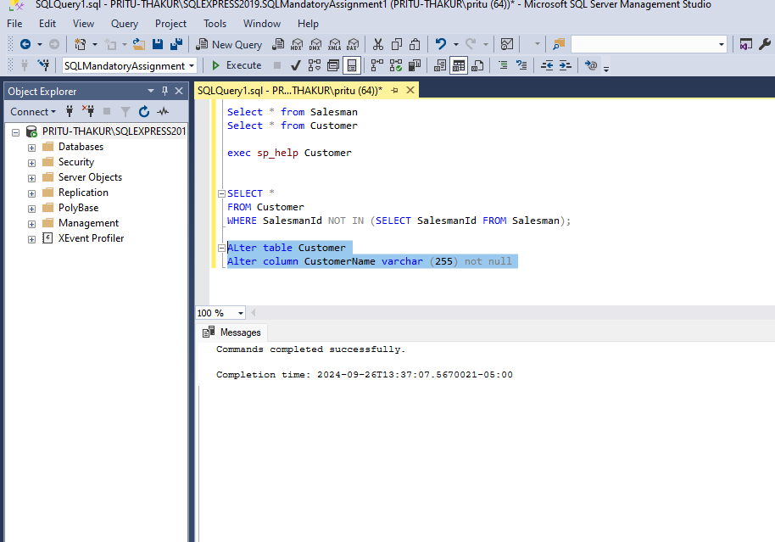
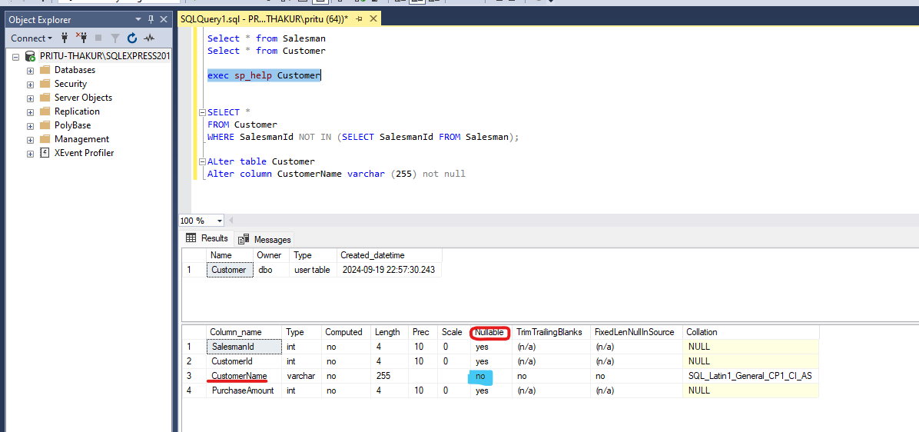

3.Fetch the data where the Customer’s name is ending with ‘N’ also get the purchase amount value greater than 500.

Query - Select* from Customer where (CustomerName like '%N') and (PurchaseAmount >500)
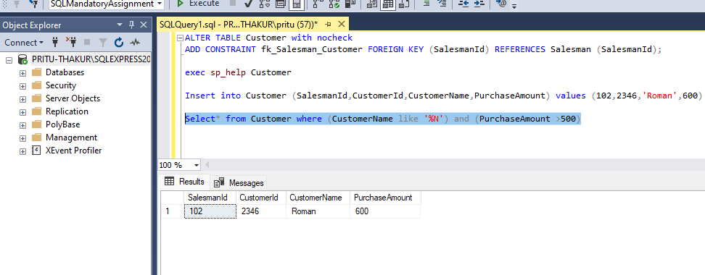

4.Using SET operators, retrieve the first result with unique SalesmanId values from two tables, and the other result containing SalesmanId with duplicates from two tables

4.a First result with unique SalesmanId values from two tables (Salesman and Customer tables)

Query - Select SalesmanId from Salesman Union (Select SalesmanId from Customer)

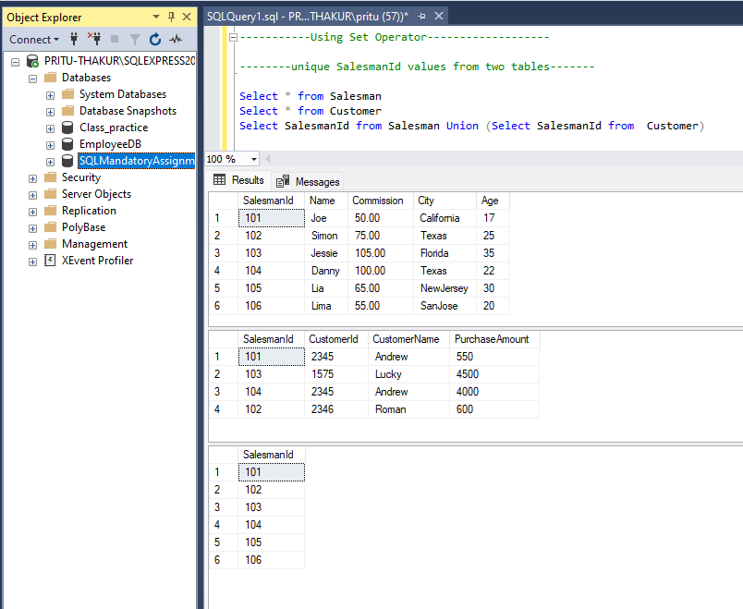
4.b Other result set containing SalesmanId with duplicates from two tables (Salesman and Customer tables)
Query - Select SalesmanId from Salesman Intersect Select SalesmanId from Customer;

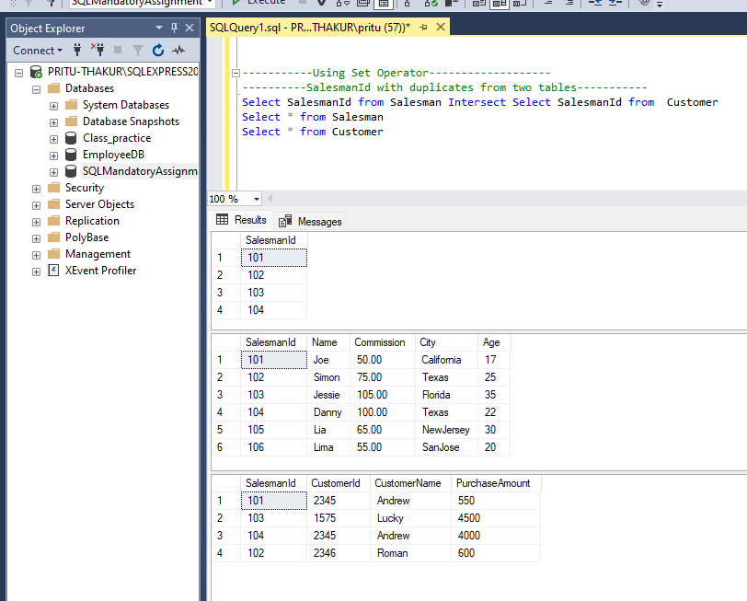

5. Display the below columns which has the matching data.
Orderdate, Salesman Name, Customer Name, Commission, and City which has the range of Purchase Amount between 500 to 1500.

Query –
Select Salesman.SalesmanId, Salesman.Name, Salesman.Commission, Salesman.City, Customer.CustomerName, Orders.OrderDate, Orders.SalesmanId from Salesman
Join Customer on Customer.SalesmanId=Salesman.SalesmanId
Join Orders on Orders.SalesmanId=Customer.SalesmanId
where Customer.PurchaseAmount between 500 and 1500

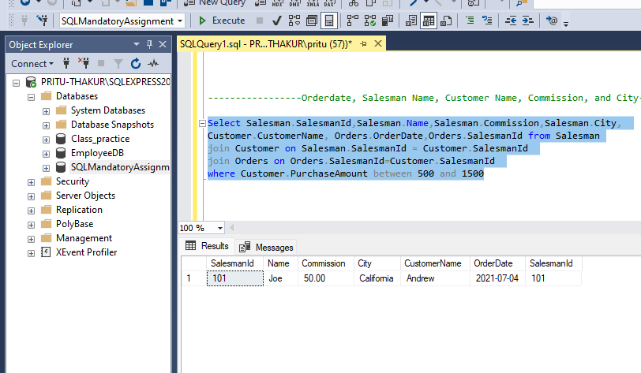
6. Using right join fetch all the results from Salesman and Orders table.

Query - Select * from Salesman Right Join Orders on Salesman.SalesmanId=Orders.SalesmanId
